**AWESOME CHOCOLATE🍫 SALES REPORT**

# **ABSTRACT**

Businesses around the globe collects their data does that for many reasons and one of the reasons is to make business decisions that will be monumental to the smooth running of the business. The annual sales report of Awesome Chocolate gives activities of their business by providing a dataset that consists of a fact table SALES which consists of 7 columns: Sales Person. Geography, Product, Date, Amount, Customers and Boxes.

Through a comprehensive analysis, I investigate the Sales pattern by each sales Person over the years given the amount of sales they made. This analysis provides valuable insights towards the customer base in each country and how they help in growing the business with their purchasing power.

# **INTRODUCTION**

This analysis aims to give deeper knowledge on how each sales person is generating revenue for the company by looking towards the sales record, monthly revenue, the products well do and product growth in each country.

The specific objectives are:

* Getting to know the TOP 10 Sales person
* Examine how well the products are generating (TOP 10)
* Investigate how to maximize the potentials in each geography in order to boost the company growth.
* And lastly, predicts how well the company will do if all potentials are maximized.

# **METHODOLOGY**

This analysis was performed using the Awesome Chocolate🍫dataset date from January 2021 to January 2022. The data was processed and analyzed using the ETL (Extract, Transform and Load) process all between Microsoft Excel and Power BI. The key metrics analyzed include, Total Customer, Total Sales, No of Products, No of Sales Rep.

The analysis includes the following key visualizations and insights:

* Total Sales by Sales Person: All together, there are 25 Sales person and the chart shows the top selling 10 with how much they make for the company.
* Total Sales by Product: Having 22 different products, the visual shows the best performing 10 in terms of sale.
* Quarterly Total Sales: This shows what was realized in terms of sales quarterly and it also predicts the next quarter as the trend shows.
* Total Sales by Country and Customers: This shows correlation in the strength of customer base and what they generate by each country.
* Awesome Chocolate sold $22M worth of goods in the dataset provided with 618,000 customers in total.

# **RESULTS**

The analysis of Awesome Chocolate dataset yielded the following significant insights:

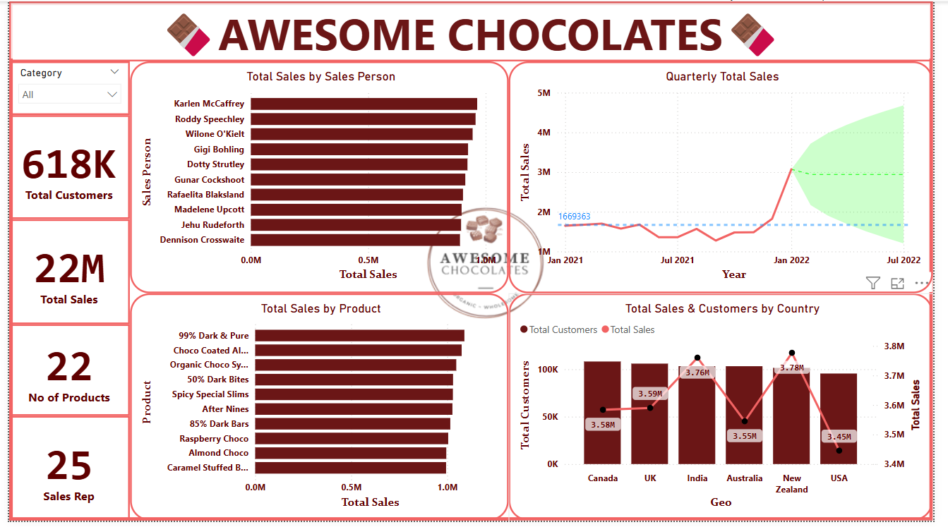

Fig 1: Dashboard showing visualization of Awesome Chocolate sales analysis.

1. The bars are our best seller in product category while the bites are not yet on their highest potential maybe because of price action or other factors.
2. Some of the countries have the customer base but not maximizing sales with the numbers
3. The is a breakout of the average sales over the year and are expected to doo more in the coming quarters.

# **CONCLUSION**

Countries like Canada and UK have the customer base but not maximizing sales with the numbers. Products that are under the bites categories too are not being maximized. The marketing team needs to get more of the products out there to customers for these products are underperforming in terms of sales. Countries customer base should be use as a tool for growth.

# **RECOMMENDATION**

It should be noted that after analysis of the Awesome Chocolate sales report, it is necessary to give insights that will aid the growth of the business. The dataset has potentials that the business can leverage on for growth. The company should work on how to maximize revenue in countries that have higher number of customers like Canada and UK. This will bring a significant upward trend in their revenue. Products that are under the bites categories too are not being maximized. Some of the products categories like bites have the customer base but not yet maximizing and this can be tapped into.